IE3-CO Lab Session #2: Preparation sheet
Surname, First Name | Group:
Emami Ali | 3
This preparation sheet must be filled and uploaded to EMIL by every student before the lab session. Cooperation within the lab team (of 2-3 students) is possible (same solution). However, no cooperation across lab teams.

Question 1:
Develop the flow chart (NSD) for the main program required for task 2.1.3. Make use of following items (add more if necessary or modify them).
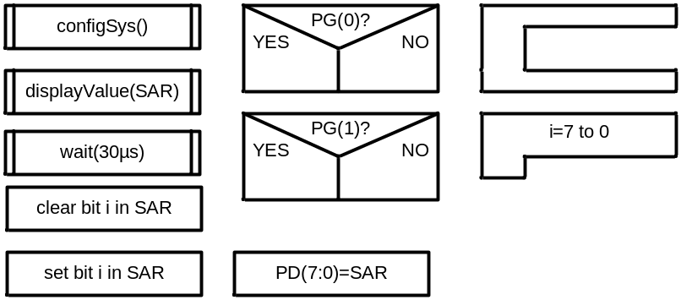
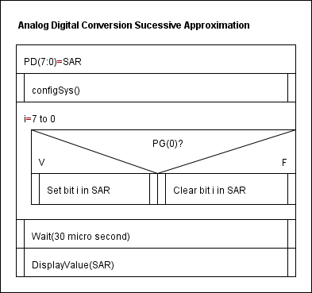

Question 2:
Develop the function configSys() which configures the ports (and timer if you want to realize the time delay by a timer):
PDDDR = 0xFF; // PORTD (7…0) is set to output
PJDDR = 0xFF; // PORTJ (7…0) is set to output
PEDDR = 0x07; // PORTE (2…0) is set to output
PGDDR =0x00; // PORTG (1…0) is set to input
PEDR = 0x00; // write the initial value for PORT E

Question 3:
Develop the function displayValue() that receives the successive approximations register value and calculates the voltage in mV. (Full range is 5V, the resolution 10 bit, see assignment sheet for details). Use integer (fix point) operations instead of floating point. Afterwards the function outputs the value in mV on the 7-segment display. For this, the voltage value (mV) has to be decomposed into decimal digits. Write the function in C (incl . conversion to mV and output to display).
void displayValue(void) // the voltage is displayed
{
PEDR |= (1<<0); // refer to EN1
PJDR = display2; // write the value to EN1
wait_for(); // wait for 30 µs
PEDR &= ~(1<<0); // EN1 is disabled
PEDR |= (1<<1); // refer to EN0
PJDR = display1; // write the value to EN0
wait_for(); // wait for 30 µs
PEDR &= ~(1<<1); // EN0 is disabled
}

Question 4:
Write the program for task 2.2.1 which includes the configuration of the ADC and the sampling of channel PE(7).
#include <stdio.h>
#include "inc/lm3s9b92.h"
void displayValue(void) // the voltage is displayed
{
PEDR |= (1<<0); // refer to EN1
PJDR = display2; // write the value to EN1
wait_for(); // wait for 30 µs
PEDR &= ~(1<<0); // EN1 is disabled
PEDR |= (1<<1); // refer to EN0
PJDR = display1; // write the value to EN0
wait_for(); // wait for 30 µs
PEDR &= ~(1<<1); // EN0 is disabled
}
int main(void)
{
int temp;
float ref_voltage;
unsigned short an0;
unsigned char display1;
unsigned char display2

SYSCTL_RCC_R = ((SYSCTL_RCC_R | 0x00000540) & ~0x000002B1);
SYSCTL_RCGC2_R |= (1<<4);
SYSCTL_RCGC0_R |= (1<<16);

GPIO_PORTE_AFSEL_R |= 0x10;
GPIO_PORTE_DEN_R &= ~0x10;
GPIO_PORTE_AMSEL_R |= 0x10;

GPIO_PORTE_DIR_R |= 0x01;
GPIO_PORTE_DEN_R |= 0x01;
GPIO_PORTE_DATA_R &= ~0x01;
do
{
ADCSR |= (1<<ADST); // A/D conversion started
while(!(ADCSR&(1<<ADF))); // wait while the A/D conversion is in process
ADCSR &= ~(1<<ADF); // ADF flag is cleared
an0 = ADDRAH << 2; // the result of A/D conversion is read
an0 |= ADDRAL >> 6; // the result of A/D conversion is read
displayValue();
}
while(PORT4&(1<<1)); // do while the stop-button wasn’t pressed

return 0;
}

